Name: _______________________________________________
Higher Unit 12 topic test
Date:
Time: 40 minutes
Total marks available: 37
Total marks achieved: ______

Questions
Q1.
The diagram shows two rectangles.
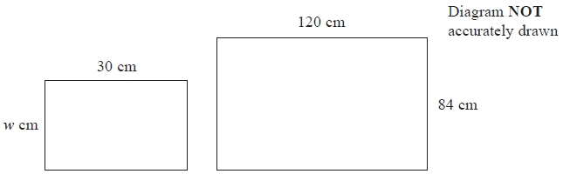
The rectangles are similar.
Work out the value of w.
...........................................................

(Total for question = 2 marks)

Q2.
Rectangle ABCD is mathematically similar to rectangle DAEF.
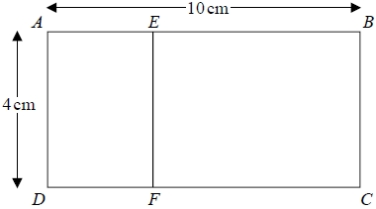
AB = 10 cm.
AD = 4 cm.
Work out the area of rectangle DAEF.
........................................................... cm²

(Total for question = 3 marks)

Q3.
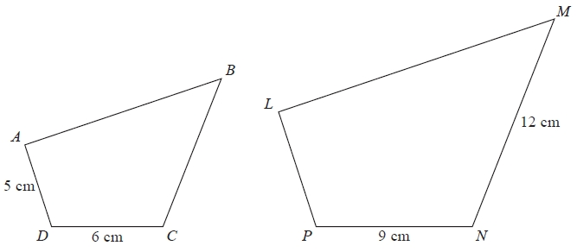
Diagram NOT accurately drawn
Quadrilaterals ABCD and LMNP are mathematically similar.
Angle A = angle L
Angle B = angle M
Angle C = angle N
Angle D = angle P
(a) Work out the length of LP.
...........................................................cm
(2)
(b) Work out the length of BC.
...........................................................cm
(2)
(Total for Question is 4 marks)

Q4.
A small photograph has a length of 4 cm and a width of 3 cm.
Shez enlarges the small photograph to make a large photograph.
The large photograph has a width of 15 cm.
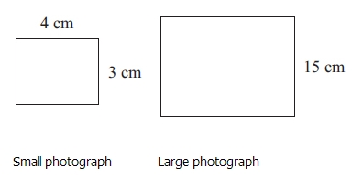 Diagram NOT accurately drawn
The two photographs are similar rectangles.
Work out the length of the large photograph.

..............................................................................................................................................
(Total for Question is 3 marks)

Q5.
ABC is a triangle.
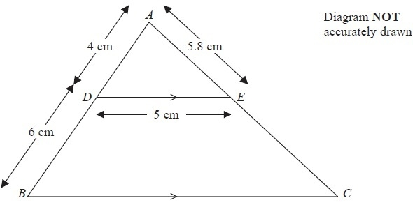
D is a point on AB and E is a point on AC.
DE is parallel to BC.
AD = 4 cm, DB = 6 cm, DE = 5 cm, AE = 5.8 cm.
Calculate the perimeter of the trapezium DBCE.
........................................................... cm
(Total for Question is 4 marks)

Q6.
Steve has a photo and a rectangular piece of card.
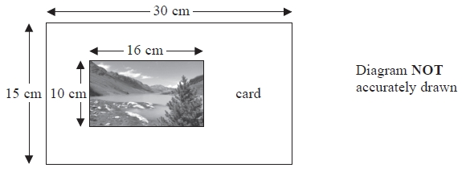
The photo is 16 cm by 10 cm.
The card is 30 cm by 15 cm.
Steve cuts the card along the dotted line shown in the diagram below.
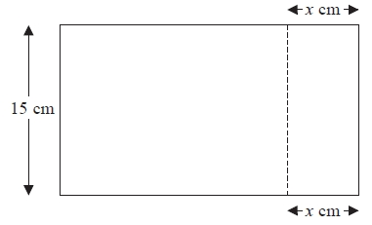
Steve throws away the piece of card that is 15 cm by x cm.
The piece of card he has left is mathematically similar to the photo.
Work out the value of x.
...........................................................
(Total for Question is 3 marks)

Q7.
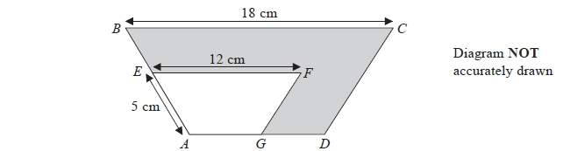
ABCD and AEFG are mathematically similar trapeziums.
AE = 5 cm
EF = 12 cm
BC = 18 cm
(a) Work out the length of AB.
........................................................... cm
(2)
Trapezium AEFG has an area of 36 cm².
(b) Work out the area of the shaded region.
........................................................... cm²
(3)
(Total for Question is 5 marks)

Q8.
The diagram shows two similar solids, A and B.
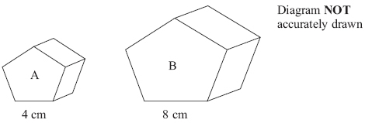
Solid A has a volume of 80 cm³.
(a) Work out the volume of solid B.

...........................................................cm³
(2)
Solid B has a total surface area of 160 cm².
(b) Work out the total surface area of solid A.

...........................................................cm²
(2)
(Total for Question is 4 marks)

Q9.
P and Q are two triangular prisms that are mathematically similar.
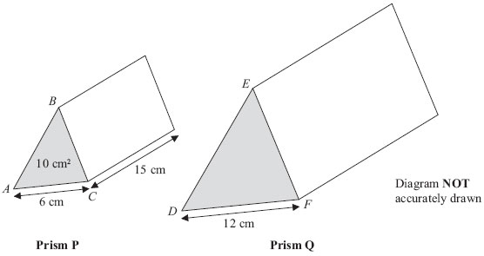
Prism P has triangle ABC as its cross section.
Prism Q has triangle DEF as its cross section.
AC = 6 cm
DF = 12 cm
The area of the cross section of prism P is 10 cm².
The length of prism P is 15 cm.
Work out the volume of prism Q.

..............................................................................................................................................
(Total for Question is 4 marks)

Q10.
Ali has two solid cones made from the same type of metal.
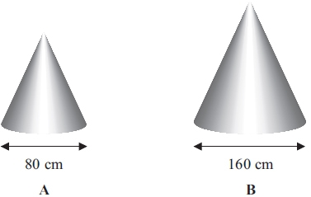 Diagram NOT accurately drawn
The two solid cones are mathematically similar.
The base of cone A is a circle with diameter 80 cm.
The base of cone B is a circle with diameter 160 cm.
Ali uses 80 ml of paint to paint cone A.
Ali is going to paint cone B.
(a) Work out how much paint, in ml, he will need.

. . . . . . . . . . . . . . . . . . . . . . ml
(2)
The volume of cone A is 171 700 cm³.
(b) Work out the volume of cone B.

. . . . . . . . . . . . . . . . . . . . . . cm³
(3)
(Total for Question is 5 marks)

Examiner's Report
Q1.
A high percentage of students completed this question on similar rectangles successfully They usually used a scale factor approach.

Q2.
No Examiner's Report available for this question

Q3.
Candidates generally scored full marks or no marks. Those who were successful usually worked out the scale factor, preferring to express this as 1.5 rather than ⁹⁄₆. Some did go on to use this incorrectly in part (b), multiplying by 1.5 instead of dividing. Using ratios of sides was rarely seen.
The most common error was to view the relationship as one involving addition and subtraction rather than a multiplicative relationship: the most frequent incorrect answers were LP = 8 and BC = 9. These results obtained from 9 − 6 = 3, and 5 + 3 = 8 and then for the second part 12 − 3 = 9

Q4.
This question was extremely well done. The most common error was omission of the units.

Q5.
Once a scale factor had been established, many candidates used it for all of their calculations and so BC = 7.5 cm (5 × 1.5) with EC = 8.7 cm was a common error. Some gave BC = 10 cm (5 × 2). Some candidates found the perimeter of triangle ABC instead of the trapezium; some credit was given if a correct scale factor had been used. Some candidates assuming an isosceles triangle, gave EC as 4.2 A significant number of candidates used cosine and sine rules to work out angles DAE, ADE and AED, usually leading to none or at most one mark.

Q6.
This question was seen by candidates often successfully as one about similarity in context. Candidates were expected to find a suitable scale factor, for example, 1.5, or to do some work on equating ratios of corresponding sides. They had to write their equation in a form which enabled them to rearrange to find the unknown side if they did use ratios before they were awarded marks.
A few candidates realised that they could turn the sheet through a right angle with respect to the photo. This was accommodated in the mark scheme.
There were many attempts to equate areas in some form. These scored no marks unless there was a reference to the square of the scale factor, for example.

Q7.
Few students were able to score more than 2 marks in this question. In part (a), most of those students who appreciated that trapezium ABCD is an enlargement of trapezium AEFG, and stated the scale factor, eg , were then able to work out the length of the side AB correctly. By far the most common incorrect approach, however, was to work out the difference in the lengths of the sides BC and EF (to get 6) and add this to the length of AE (to get 11). In part (b), relatively few students knew that they were required to use the area scale factor for the enlargement. A common incorrect approach was to increase the area of trapezium AEFG by the linear scale factor (to get 54) and then either give this as the final answer, or subtract 36 from this to get an incorrect final of 18. A significant number of those students who appreciated that they needed to use the area scale factor for the calculation were unable to do this correctly, eg by not being able to calculate 1.5 × 1.5 correctly, or by giving the final answer as the total area of the trapezium ABCD rather than as the shaded area. A very common incorrect approach was to use the area of a trapezium formula in an attempt to find the areas.

Q8.
Correct answers were rare in this question, with most candidates incorrectly assuming a scale factor of 2 and giving the answers 160 and 80. Attempts to work out the surface area or the volume frequently led nowhere.

Q9.
This question was answered poorly by all but the best candidates. Candidates usually found the correct length of the larger prism but then also doubled the cross sectional area rather than multiplying it by 4, so answers of 600 with or without units were often seen. A small number of candidates successfully answered the question by working out the vertical height of the triangle ABC, doubling the dimensions of the prism then working out the volume of the larger prism. A large number of candidates were able to score at least one mark for stating the correct units.

Q10.
Part (a) was poorly answered, the majority giving 80 × 2 = 160. One reason might have been that candidates did not associate paint with area.
Greater success was found with part (b). Many used a scale factor 8 correctly to find the answer. Many also chose a circuitous route of working with volumes of cones to find the answer; a minority trying this route used prematurely rounded figures and therefore failed to reach an accurate final answer.

Mark Scheme
Q1.
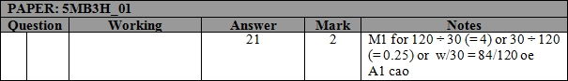

Q2.
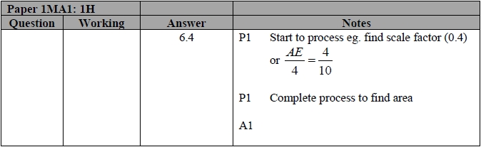

Q3.
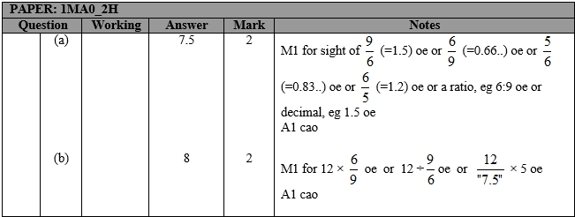

Q4.
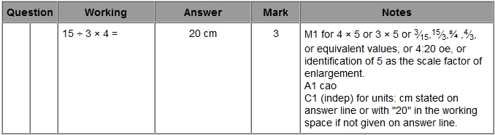

Q5.
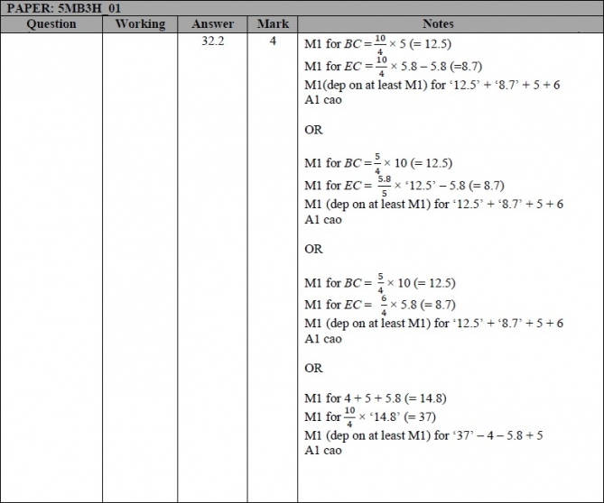

Q6.
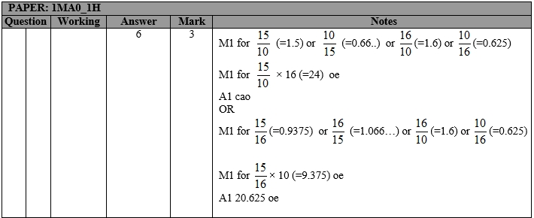

Q7.
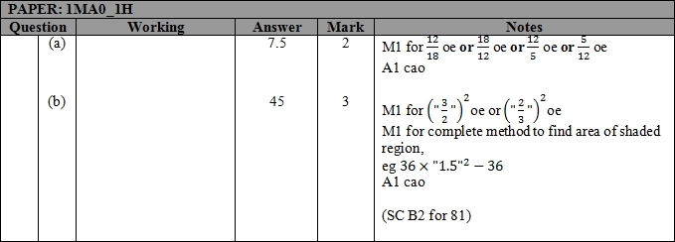

Q8.
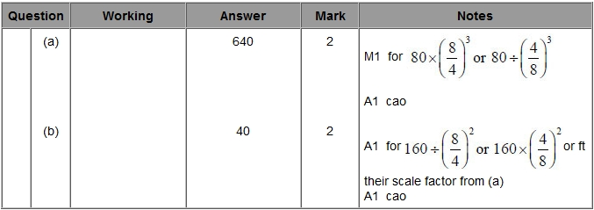
Q9.
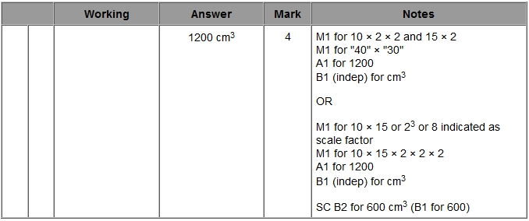

Q10.
